Technical University of Cluj-Napoca
Faculty of Automation and Computer Science
Year: 2011-2012 2nd semester

FIFO Memory

Student: Șutea Marius
Group: 30414

1.Specification

  - Task
Implement the FIFO memory designs, according to the documentation in the book: „Proiectarea sistemelor numerice folosind tehnologia FPGA” by S. Nedevschi, Z. Baruch and O. Creţ, at page 238.

  - Task analysis
In order to implement a FIFO memory four main logic blocks are needed: Control, Status, Pointers and Memory Array. There will be three inputs: PUSH, POP and DATAIN and four outputs: DATAOUT, EMPTY, FULL and LAST. The LAST signal is needed in case if after a write operation the queue becomes full.
The control logic is needed to generate read and write enables. In case of single port implementation, if both PUSH and POP operations are active then the POP will be ignored and the PUSH will be performed. If the design is dual port then both operations can be executed at the same time.
Status is needed to determine if the queue is empty, full or if one more element may be added before the queue is full. The number of bits is stored in a 4-bit binary up-down counter which is incremented by a write and decremented by a read. There are seventeen states for the FIFO: empty(0 bytes), 1-15 bytes and full(16 bytes). A 5-bit counter is not needed though, because the full and empty states are shown by the FULL and EMPTY outputs
The write and read pointers are used for determining the address of the operation that is executed(the read address and the write address). The read pointer is incremented by a read operation and the write pointer is incremented by a write operation. The pointers are stored in standard 4-bit binary up counters.
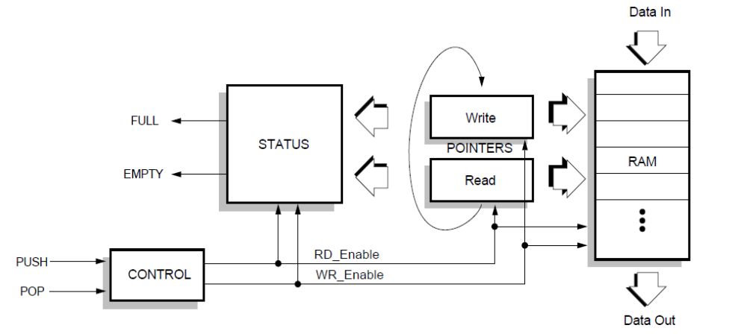
The memory array is 16 bits deep and 4 bits wide. The WE input latches the data into the RAM on the falling edge of the PULSE signal. The number of bits can be extended to create a wider RAM. Increasing the number of words requires changes to the status logic, additional address lines and larger read and write pointers.
2.Block Diagram

  - Block diagram analysis
The block diagram shows how to implement the FIFO memory. The control logic converts the PUSH and POP inputs into write and read enables. For the single port designs the control needs a clock signal clocked at half the speed of the external clock. The RD_Enable and WR_Enable signals are needed enable the read and write operations, to determine the status of the FIFO queue. They also increment the write and read pointers. The status shows if the queue is empty or full. If the queue is empty then the POP operation can't be executed since there are no elements in the queue. Also, if the queue is full, PUSH can not be executed. A LAST signal is also needed for the status to determine if at most one word(which may already be on the way) can be inserted. The RAM block uses the pointers to determine the addresses(which are multiplexed in case of single port implementation). The data is latched into the RAM by the WE signal, which depends on the PULSE clock signal for the FIFOA design.

3.List of components
The components that were used in the design are the following: counters, flip-flops, multiplexers and logic gates.
- Counters
There were two types of counters used:
  - A 4-bit binary up-down counter(C4UD) which was used to determine the status. The counter is incremented by a write operation, decremented by a read operation and is not affected by a simultaneous read and write.
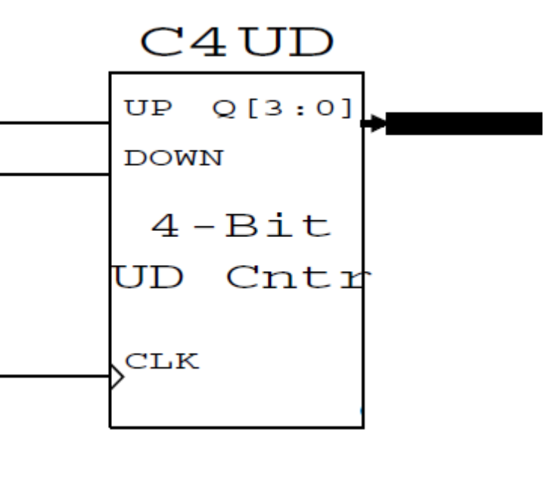
The counter has three inputs: up and down which determine the direction in which the counter counts, and clk which represents the counter's clock signal. In this case the up input will be the „write enable” signal and the down input will be the „read enable” signal. The outputs (Q3, Q2, Q1, Q0) are used to determine if the queue is empty, full or if only one element can be added to the queue.
  - Two 4-bit binary up counters (one for read and one for write). The read pointer is incremented by a read, while the write pointer is incremented by a write. The two pointer addresses are multiplexed to create the address for the RAM block.
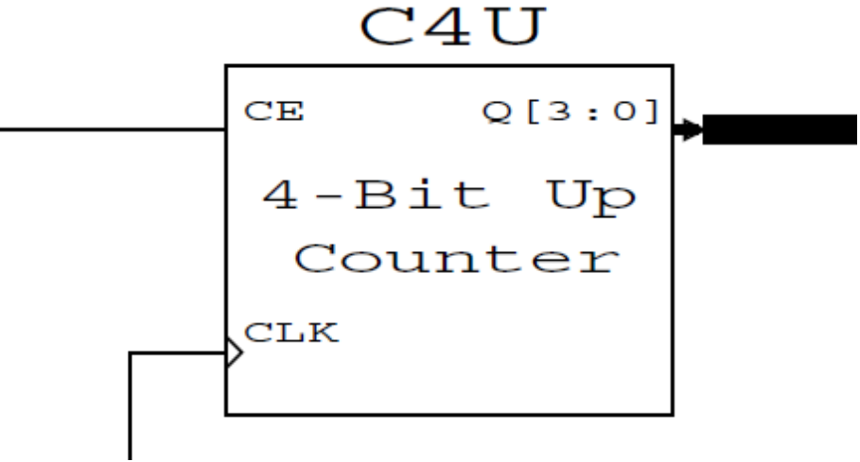
The counter has two main inputs: CE and CLK
If the CE input(Count Enable) is '0' the the counter won't count. Once the CE input becomes '1' the the counter will activate and will count to 15. By adding logic gates the interval in which the counter counts can be changed.
The CLK input is known as clock. The values of the outputs will change only if the clock has the value '1'.
- Flip-flops
All the flip-flops that are used in the project are D flip-flops. They are used in all parts of the designs (control, read and write pointers, status).

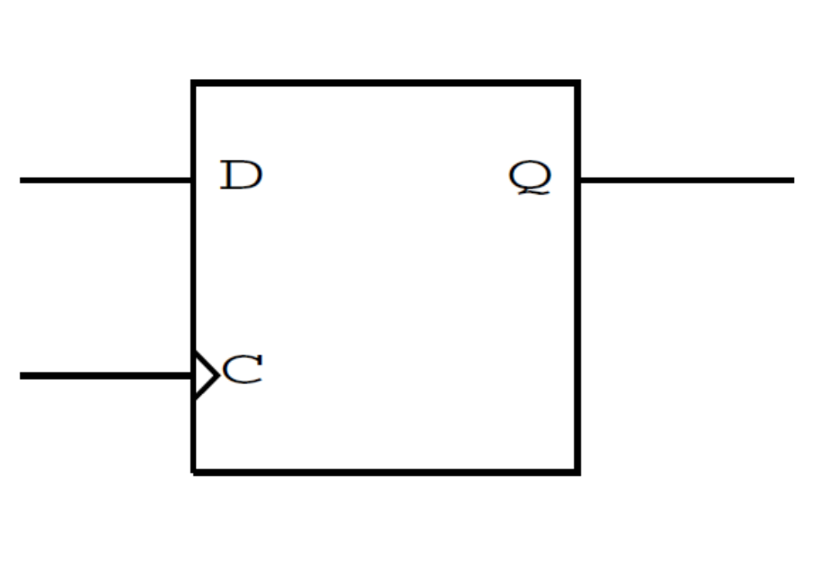
The D flip-flop has two inputs: D and C. C is the clock of the flip-flop.
- Multiplexers
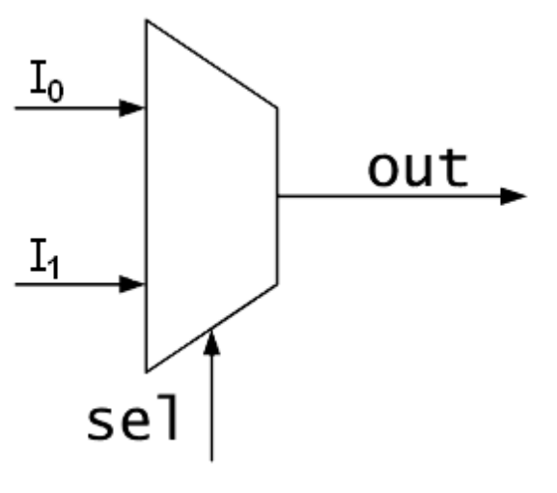
The 2:1 multiplexers are used in the up-down counter scheme and in the FIFOA memory array to determine if the operation is read or write.

The multiplexers can be of many types: 2:1, 4:1, 8:1, 16:1. In general the multiplexer has n inputs and m selections. The relation between the number of inputs and the number of selections is n=2^{m}. The selection inputs determine the input which will be shown at the output. For example, if the multiplexer is 8:1, and the selections are ”101” then the fifth input will be shown.
- Logic gates
The logic gates that are used are: AND gates, XOR gates, OR gates and NOT gates. The truth tables for each of the functions are shown below:
  - AND gate
A | B | Y
0 | 0 | 0
0 | 1 | 0
1 | 0 | 0
1 | 1 | 1

  - OR gate
A | B | Y
0 | 0 | 0
0 | 1 | 1
1 | 0 | 1
1 | 1 | 1
  - XOR gate
A | B | Y
0 | 0 | 0
0 | 1 | 1
1 | 0 | 1
1 | 1 | 0
  - NOT gate
A | Y
0 | 1
1 | 0

4.Code explanation
  - Inputs and outputs
clk: std_logic; - external clock
push: std_logic; - push signal which allows inserting in the queue;
pop: std_logic; - pop signal which allows removing from the queue;
datain: std_logic_vector(3 downto 0); - data to be inserted in the queue;
dataout: std_logic_vector(3 downto 0); - data read/removed from the queue;
empty: std_logic; - signal that shows if the queue is empty and that the pop operation can't be executed;
last: std_logic; - signal which indicates that if one more element is inserted the queue becomes full;
full: std_logic; - signal that shows if the queue is full and that no element can be inserted in the queue;
  - Components
    - Up-Down Counter
entity up_down_counter is
port(up, down, clkc: in std_logic;
qc: out std_logic_vector(3 downto 0));
end up_down_counter;

architecture ar_up_down_counter of up_down_counter is
begin
process(clkc,up,down)
variable v:std_logic_vector(3 downto 0):="0000";
begin
if clkc='1' and clkc'event then
if up='1' and down='0' then
v:=v+"0001";
elsif down='1' and up='0' then
v:=v-"0001";
else null;
end if;
end if;
qc<=v;
end process;
end ar_up_down_counter;

This counter uses only one signal and a variable inside a process. If up is '1' then the variable is added with „0001” and if down is '1' the variable is decremented.

    - Up Counter
entity up_counter is
port(ce, clk2: in std_logic;
qe: out std_logic_vector(3 downto 0));
end up_counter;

architecture ar_up_counter of up_counter is
begin
process(clk2,ce)
variable v1:std_logic_vector(3 downto 0):="0000";
begin
if clk2='1' and clk2'event and ce='1' then
v1:=v1+"0001";
else null;
end if;
qe<=v1;
end process;
end architecture ar_up_counter;

Same as the up-down counter this counter uses a variable which is added with „0001” if CE is '1'.

    - D flip-flop
entity d_flipflop is
port(d, clk1: in std_logic;
qd : buffer std_logic);
end d_flipflop;

architecture d of d_flipflop is
signal s1,s2: std_logic;
begin
N1: process(clk1)
begin
s1<=not(clk1);
end process N1;
NAND1: process(s1, clk1)
begin
s2<=s1 nand clk1;
end process NAND1;
D1: process(s2)
begin
if S2='1' then
qd<=d;
end if;
end process D1;
end architecture d;

The architecture consists of three processes which are made from the internal scheme of the D flip-flop.

    - 2:1 multiplexer
entity mux2to1 is
Port ( A : in std_logic;
B : in std_logic;
S : in std_logic;
Y : out std_logic);
end mux2to1;

architecture ar_mux of mux2to1 is
begin
process(A, B, S)
begin
if(S = '1') then
Y <= A;
else
Y <= B;
end if;
end process;
end ar_mux;

This architecture also uses a process. Since the multiplexer is a 2:1 one then we don't have to use many if/else statements.

  - Main Unit
The entity contains the inputs and the outputs presented in the section 4.1. EMPTY, FULL, and LAST outputs are declared as buffers because they are also used to determine the POP and PUSH. DATAIN and DATAOUT are of type std_logic_vector and POP and PUSH are of std_logic type.
entity fifoa is
port(clk: in std_logic;
push: in std_logic;
pop: in std_logic;
datain: in std_logic_vector(3 downto 0);
dataout: out std_logic_vector(3 downto 0);
empty: buffer std_logic;
last: buffer std_logic;
full: buffer std_logic);
end fifoa;

The schemes also use many intermediate signals between the inputs and the outputs. The signals of the single port level sensitive scheme (FIFOA) are the following:
signal ram: memory:=(others=>(others=>'0'));
signal ce_rd, rd_op: std_logic;
signal ce_wr, wr_op: std_logic;
signal ph1, ph2: std_logic;
signal a,b,c,d,e,f,g,gt,h,i: std_logic;
signal nclk: std_logic;
signal s0,s2: std_logic;
signal aw,ar,ad: std_logic_vector(3 downto 0);
signal pulse,we: std_logic;
signal q,datainq: std_logic_vector(3 downto 0);

The ram signal has the type memory. It is used for the memory array. ce_rd and ce_wr are the read and write enable signals after verifying if the queue is not empty/full(the final enable signals) ; rd_op and wr_op are the read and write enable signals before verifying if the queue is empty/full. PH1 and PH2 are the half-speed clock signals which are used for the FIFOA architecture. The a,b,c,d,e,f,g,gt,h and i are intermediate signals used to avoid too long expressions. NCLK is the inverse of the external clock. It is used to generate the PH1 clock. S0 and S2 are also used to avoid long expressions. AW is the write address, AR is the read address and AD is the address of the operation selected by the wr_op signal. PULSE determines the WE signal which latches the data into the RAM. Q is the output of the up-down counter which is used to determine the status. DATAINQ is the delayed data input. The reason for which the input is delayed is because that it needs to synchronize with the WE signal.

The signals for the dual port implementation are the following:
signal ram: memory:=(others=>(others=>'0'));
signal ce_wr, ce_rd: std_logic;
signal a,b,c,d,e: std_logic;
signal q: std_logic_vector(3 downto 0);
signal s0,s2: std_logic;
signal aw,ar: std_logic_vector(3 downto 0);
As it can be seen there are considerably fewer signals than in the single port implementation and most of the signals are the same. The address signal is not needed since the data can be both written and read at the same time. Also the PH1 and PH2 clock are not needed.
    - Control
The control logic is not the same for all designs. The control for the FIFOA design is the following:
h<=not(g);
ph1<= g;
ph2<= i;
nclk<=not(clk);
gt<=g;
P2: d_flipflop port map(gt, nclk, i);
P1: d_flipflop port map(h, clk, g);

x1: d_flipflop port map(push, ph1, wr_op);
ce_wr<=wr_op and (not(full));
f<=pop and (not(push));
x2: d_flipflop port map(f, ph1, rd_op);
ce_rd<=rd_op and (not(empty));

The first part generates the ph1 and ph2 clock signals. The second part is the actual control scheme. The D flip-flops are used because the signals have to synchronize to the ph1 clock.
The dual port control is much simpler that the single port one:
ce_wr<= push and not(full);
ce_rd<= pop and not(empty);
The control is reduced to two concurrent statements. If PUSH is '1' and the queue is not full then write is enabled. Similarly, if POP is '1' and the queue is not empty then read is enabled.
    - Status
The status is the same for all the designs. The VHDL code for the status is written below:
Z: up_down_counter port map(ce_wr, ce_rd, clk, q);
a<= q(0) and not(q(1)) and not(q(2)) and not(q(3));
c<= q(3) and q(2) and q(1);
s0<= a and ce_rd;
d<= (last and not(ce_rd) and not(ce_wr)) or (ce_wr and c) or (not(c) and last and ce_rd);
b<= (s0 and empty) and not(ce_wr);
s2<= ce_wr and last;
e<= (s2 and full) and not(ce_rd);
E1: d_flipflop port map(b, clk, empty);
L1: d_flipflop port map(d, clk, last);
F1: d_flipflop port map(e, clk, full);

If q is 0001 and read is enabled, it means that the queue is empty. If q is 1110 and write is enabled then the LAST signal becomes 1. If LAST is 1 and write is enabled then the FIFO queue is full.
    - Pointers and memory array
This part is also different depending on the design. The code for the FIFOA scheme is the following:
U1: up_counter port map(ce_wr, ph1, aw);
U2: up_counter port map(ce_rd, ph1, ar);
MUXG: for I in 3 downto 0 generate
MUX: mux2to1 port map(aw(I), ar(I), wr_op, ad(I));
end generate;
pulse<=ph2 and not(ph1);
we<=pulse and ce_wr;
DFG: for I in 3 downto 0 generate
DF: d_flipflop port map(datain(I), ph1, datainq(I));
end generate;
MEM: process(we, ad)
begin
if we='1' then
ram(conv_integer(ad))<=datain ;
else
dataout<=ram(conv_integer(ad));
end if;
end process MEM;
To determine which of the operations will be executed, the addresses need to be multiplexed. The outputs of the counters are on 3 bits, so the generate instruction is used. The generate instruction is also used for the D flip-flops in which DATAIN is the input and DATAINQ is the output. If the WE signal has the value '1' then the data will be inserted into the RAM. If it has the value '0' then the data will be read from RAM.
The pointers and the memory array for the FIFOD design are the following:
U1: up_counter port map(ce_wr, clk, aw);
U2: up_counter port map(ce_rd, clk, ar);
MEM1: process(ce_wr, aw, clk)
begin
if (clk'event and clk='1' and ce_wr='1') then
ram(conv_integer(aw))<=datain;
elsif (clk'event and clk='1' and ce_rd='1') then
dataout<=ram(conv_integer(ar));
end if;
end process MEM1;
The instructions are the same as for the FIFOA design, except that the generate statements and the pulse are not needed.
- Justifying the solution
The solution was easier to implement because the structural description, which is the most used in the project, can be done just by looking closely at the block diagram and the components needed for each of the designs. For the components (counters, flip-flops, multiplexers) the behavioral description was chosen because it is easier to understand than the structural description. The structural description was preferred for the FIFO designs because the differences between the designs are easier to show. The „data flow” design is also used in the project to determine the signals when using logic gates. The reason for choosing this is that is simpler than using processes or components for each logic gate.
5.1. Further Development
The scheme can be developed to show how many elements are in the queue. The number of bits of the RAM can be easily extended to create a wider RAM. To increase the FIFO depth, additional address lines, larger read and write pointers and changes to the status logic are required.

